April 23, 2025

Dr. Maria Miriti
Vice Provost and Dean for Graduate Education
Graduate School,
250 University Hall, 230 North Oval Mall
Columbus, OH 43210

Dear Dr. Miriti,
Thank you for your submission, on behalf of The Ohio State University, requesting the following changes:

- Master of Arts in Speech Language Pathology – Curriculum Change

On April 18, 2025, the Chancellor’s Council on Graduate Studies formally approved this request effective immediately. No further action is needed at this time. Please contact me at (614) 466-0886 or snameth@highered.ohio.gov if our office can be of further assistance.
Thank you for your continued support of graduate education in Ohio.

Sincerely,
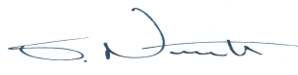
Steve Nameth
Director
Graduate Program

